

CS-250: Lab 06
AVL Trees

Muhammad Mujtaba
CMD ID: 540040
mmujtaba.bese25seecs@seecs.edu.pk

  - Class: BESE 16B
  - Batch: 2k25

AVL Tree DS Used:
See avl_tree.hpp and avl_tree.cpp
GitHub Repo Link: https://github.com/mmujtaba25/CS-250
Zip File for only Lab 06: https://github.com/mmujtaba25/CS-250/releases/tag/lab-06

Task 1:
See avl_tree.hpp, avl_tree.cpp and main.cpp.
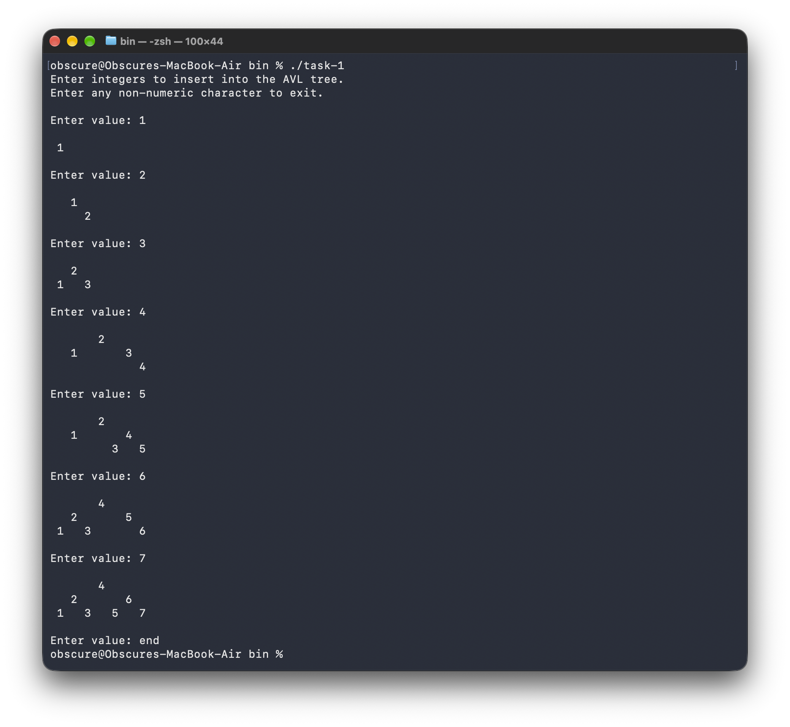

Task 1 Driver (task1.cpp):
#include "avl_tree.hpp"

#include <print>
#include <iostream>
#include <string>
#include <cstdio>

void printTree(const AVLTree &tree);
void printLevel(const AVLTreeNode *node, int level, int spacing);

int main()
{
AVLTree tree;

std::println("Enter integers to insert into the AVL tree.");
std::println("Enter any non-numeric character to exit.\n");

while (true)
{
int value;

std::print("Enter value: ");
std::fflush(stdout);

if (!(std::cin >> value))
break;

tree.insert(value);

std::println();
printTree(tree);

std::println();
}

return 0;
}

// MARK: Helpers

void printLevel(const AVLTreeNode *node, int level, int spacing)
{
if (level == 0)
{
std::print("{:^{}}", node ? std::to_string(node->data) : " ", spacing);
return;
}

// recursively print each levvel
printLevel(node ? node->left : nullptr, level - 1, spacing);
printLevel(node ? node->right : nullptr, level - 1, spacing);
}

void printTree(const AVLTree &tree)
{
const AVLTreeNode *root = tree.root();

if (root == nullptr)
return;

int height = root->height;

for (int level = 0; level < height; level++)
{
int spacing = 4 * (1 << (height - level - 1));

printLevel(root, level, spacing);

std::println();
}
}

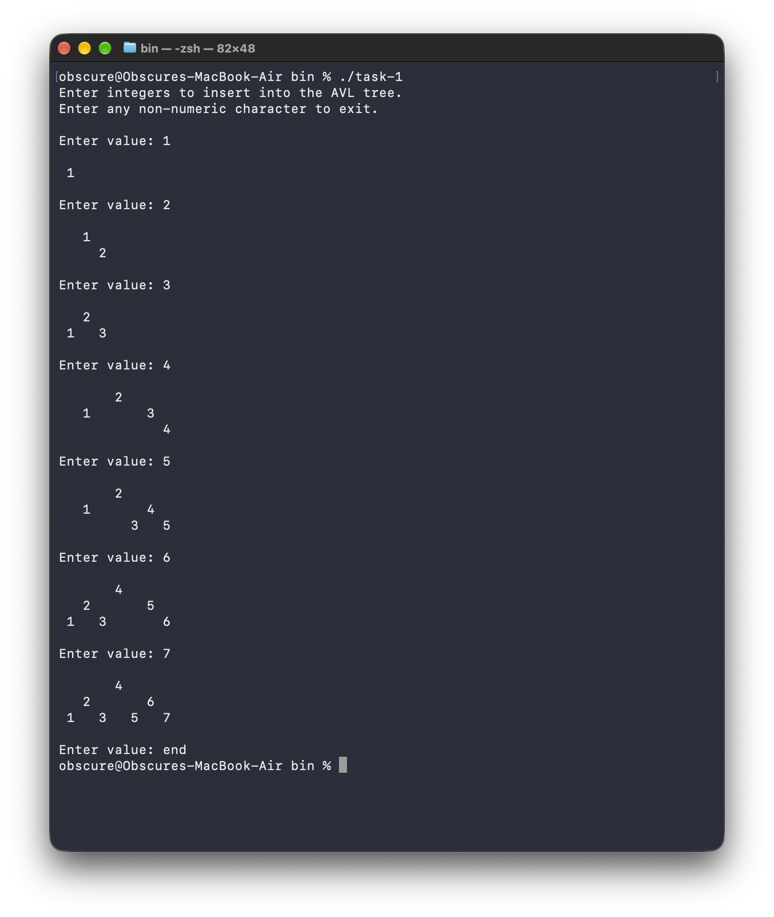Task 2:
See avl_tree.hpp, avl_tree.cpp and task2.cpp.
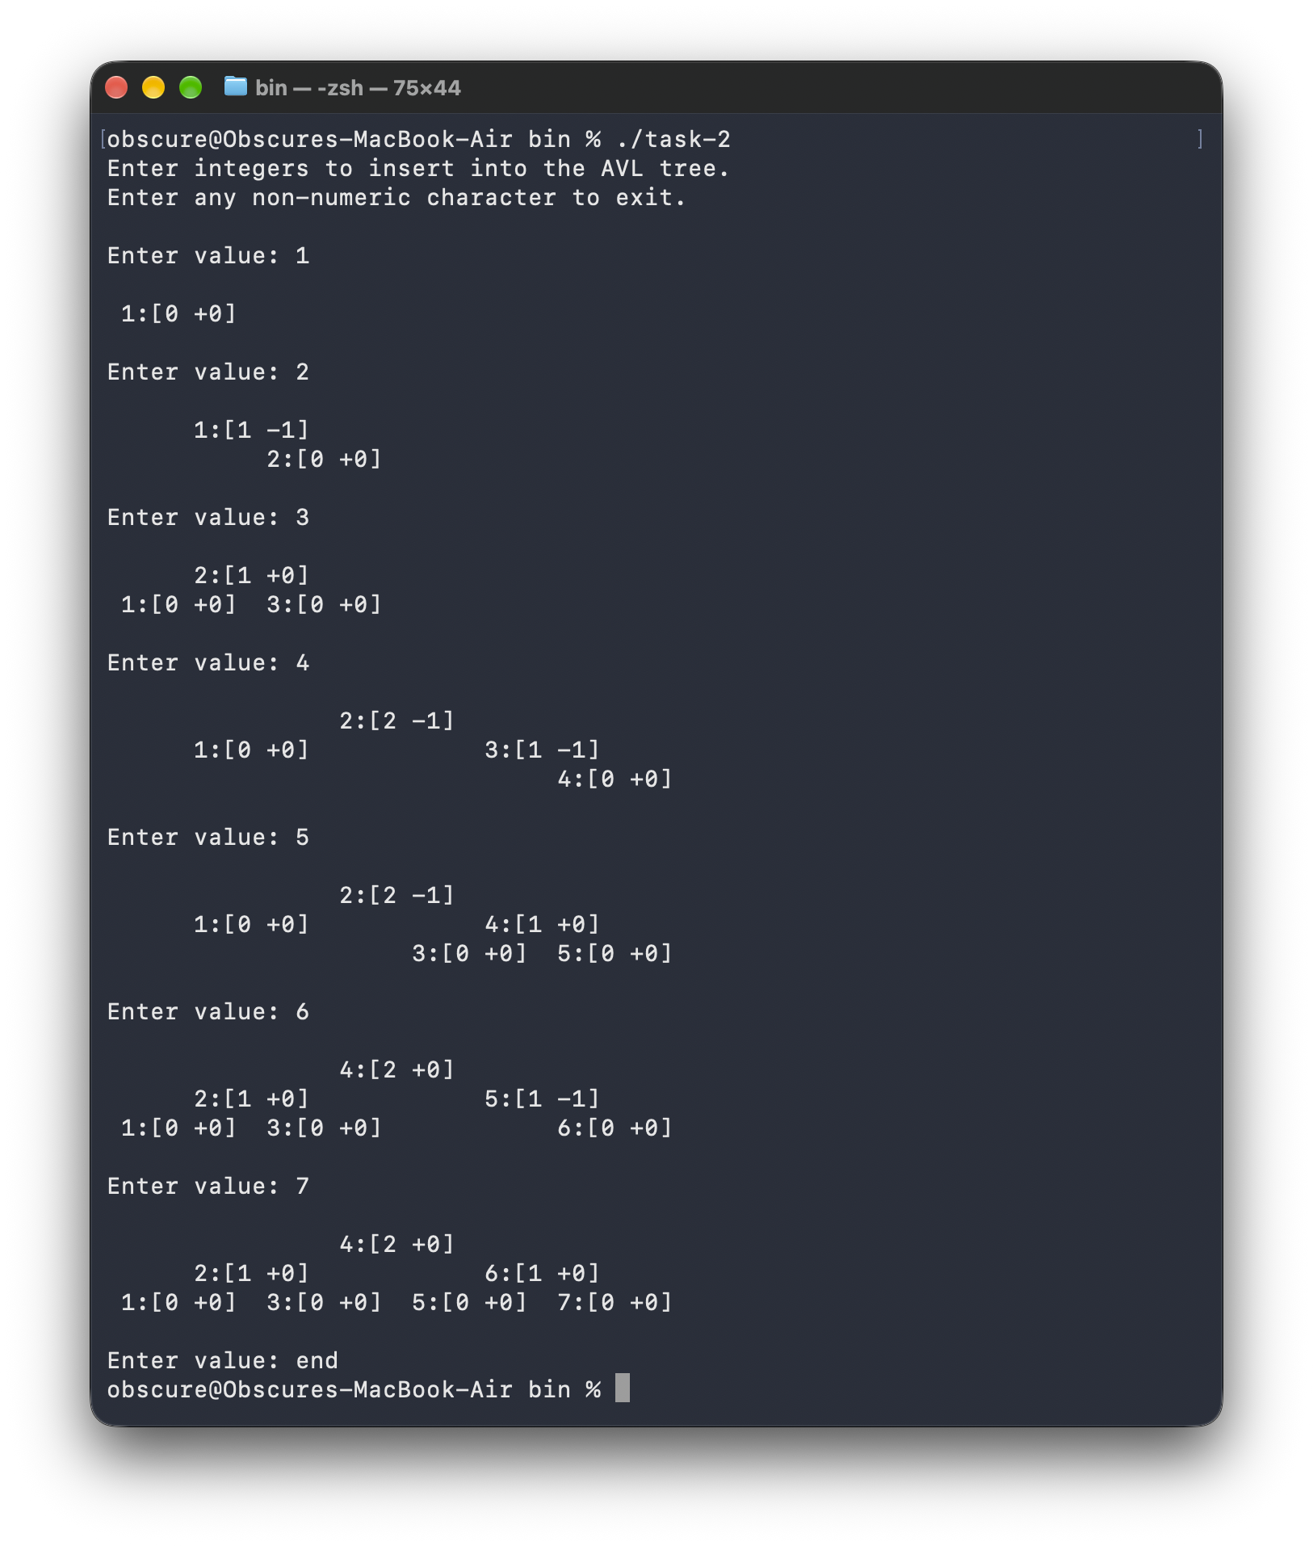

Task 2 Driver (task2.cpp):
#include "avl_tree.hpp"

#include <print>
#include <format>
#include <iostream>
#include <string>
#include <algorithm>
#include <cstdio>

std::string nodeLabel(const AVLTreeNode *node);
size_t maxLabelWidth(const AVLTreeNode *node);

void printTree(const AVLTree &tree);
void printLevel(const AVLTreeNode *node, int level, int spacing);

int main()
{
AVLTree tree;

std::println("Enter integers to insert into the AVL tree.");
std::println("Enter any non-numeric character to exit.\n");

while (true)
{
int value;

std::print("Enter value: ");
std::fflush(stdout);

if (!(std::cin >> value))
break;

tree.insert(value);

std::println();
printTree(tree);

std::println();
}

return 0;
}

// MARK: Helpers

std::string nodeLabel(const AVLTreeNode *node)
{
if (node == nullptr)
return "";

int leftHeight = node->left ? node->left->height : 0;
int rightHeight = node->right ? node->right->height : 0;

int balance = leftHeight - rightHeight;

return std::format("{}:[{} {:+}]", node->data, node->height - 1, balance);
}

size_t maxLabelWidth(const AVLTreeNode *node)
{
if (node == nullptr)
return 1;

return std::max({nodeLabel(node).size(), maxLabelWidth(node->left), maxLabelWidth(node->right)});
}
void printLevel(const AVLTreeNode *node, int level, int spacing)
{
if (level == 0)
{
std::print("{:^{}}", nodeLabel(node), spacing);
return;
}

// recursively print each levvel
printLevel(node ? node->left : nullptr, level - 1, spacing);
printLevel(node ? node->right : nullptr, level - 1, spacing);
}

void printTree(const AVLTree &tree)
{
const AVLTreeNode *root = tree.root();

if (root == nullptr)
{
std::println("(empty)");
return;
}

int height = root->height;
int width = static_cast<int>(maxLabelWidth(root)) + 2;

for (int level = 0; level < height; level++)
{
int spacing = width * (1 << (height - level - 1));

printLevel(root, level, spacing);

std::println();
}
}

